Assignment1 : Implement DFS, BFS for 8-Puzzle Problem

Problem Statement:
Implement Depth First Search (DFS) and Breadth First Search (BFS) algorithms to solve the 8-puzzle problem.

Objectives:
- To understand the working principles of DFS and BFS algorithms.
- To implement and compare their performance in solving the 8-puzzle problem.

Theory:
Methodology:
In the 8-puzzle problem, the objective is to transform a given initial configuration of tiles into the goal configuration by sliding tiles into the empty space (represented by 0).
- Depth First Search (DFS) explores each branch of the search tree as deeply as possible before backtracking.
- Breadth First Search (BFS) explores all neighboring nodes (possible moves) at the current level before proceeding to the next level.
Both algorithms systematically explore the state space until the goal state is reached.

Working Principle / Algorithm:
DFS Algorithm:
- Start with the root node representing the initial configuration.
- Expand one branch as deep as possible into the state space.
- If no further moves are possible, backtrack to the previous state.
- Continue this process until the goal configuration is reached or all possible configurations are explored.
BFS Algorithm:
- Begin with the root node representing the initial configuration.
- Explore all possible moves from the current state.
- Move to the next depth level and continue exploring states in order of their discovery.
- Repeat until the goal configuration is reached.

Advantages:
- DFS: Uses less memory and is suitable for deep searches.
- BFS: Guarantees finding the shortest solution path in an unweighted search space.

Disadvantages / Limitations:
- DFS: May not find the shortest path and can get stuck in deep or infinite branches.
- BFS: Consumes a large amount of memory for wider or deeper search spaces.
Diagram:
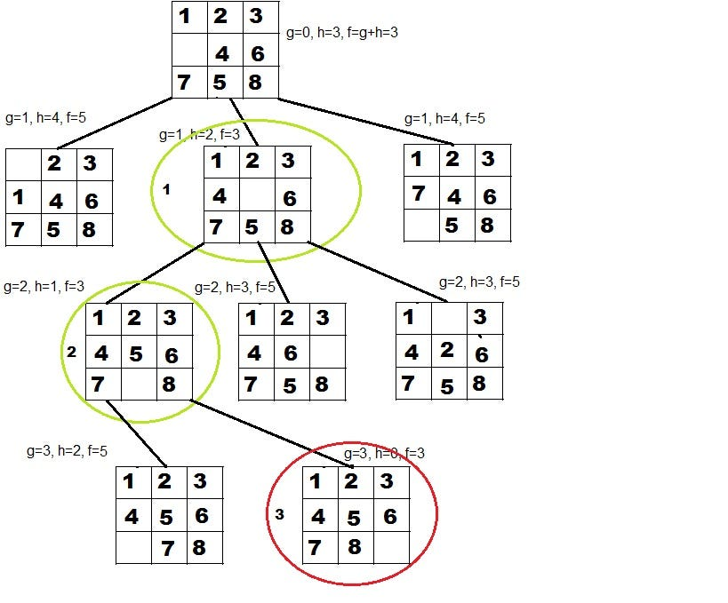

Conclusion:
DFS and BFS are effective search algorithms for the 8-puzzle problem. However, BFS ensures the shortest path, while DFS may consume less memory for deep searches.
Code :
import java.util.*;

public class EightPuzzle {

static String goal = "123456780"; // Goal state (0 = empty tile)
static int[][] moves = { {1,0}, {-1,0}, {0,1}, {0,-1} }; // Down, Up, Right, Left

// Display board
static void printBoard(String state) {
for (int i = 0; i < 9; i++) {
System.out.print(state.charAt(i) + " ");
if ((i + 1) % 3 == 0) System.out.println();
}
System.out.println();
}

// Generate all possible next states
static List<String> getNeighbors(String state) {
List<String> neighbors = new ArrayList<>();
int zeroIndex = state.indexOf('0');
int x = zeroIndex / 3;
int y = zeroIndex % 3;

for (int[] m : moves) {
int nx = x + m[0], ny = y + m[1];
if (nx >= 0 && nx < 3 && ny >= 0 && ny < 3) {
int newIndex = nx * 3 + ny;
char[] arr = state.toCharArray();
char temp = arr[zeroIndex];
arr[zeroIndex] = arr[newIndex];
arr[newIndex] = temp;
neighbors.add(new String(arr));
}
}
return neighbors;
}

// ---- BFS Implementation ----
static void bfs(String start) {
Queue<List<String>> queue = new LinkedList<>();
Set<String> visited = new HashSet<>();

queue.add(Arrays.asList(start));

while (!queue.isEmpty()) {
List<String> path = queue.poll();
String current = path.get(path.size() - 1);

if (current.equals(goal)) {
System.out.println("BFS Solution found in " + (path.size() - 1) + " moves.\n");
for (String step : path) printBoard(step);
return;
}

if (!visited.contains(current)) {
visited.add(current);
for (String neighbor : getNeighbors(current)) {
if (!visited.contains(neighbor)) {
List<String> newPath = new ArrayList<>(path);
newPath.add(neighbor);
queue.add(newPath);
}
}
}
}
System.out.println("No solution found using BFS.");
}

// ---- DFS Implementation ----
static void dfs(String start, int depthLimit) {
Stack<List<String>> stack = new Stack<>();
Set<String> visited = new HashSet<>();

stack.push(Arrays.asList(start));

while (!stack.isEmpty()) {
List<String> path = stack.pop();
String current = path.get(path.size() - 1);

if (current.equals(goal)) {
System.out.println("DFS Solution found in " + (path.size() - 1) + " moves.\n");
for (String step : path) printBoard(step);
return;
}

if (path.size() > depthLimit) continue;

if (!visited.contains(current)) {
visited.add(current);
for (String neighbor : getNeighbors(current)) {
if (!visited.contains(neighbor)) {
List<String> newPath = new ArrayList<>(path);
newPath.add(neighbor);
stack.push(newPath);
}
}
}
}
System.out.println("No solution found using DFS (depth limit reached).");
}

// ---- MAIN ----
public static void main(String[] args) {
String start = "123406758"; // Example start state
System.out.println("Start State:");
printBoard(start);
System.out.println("Goal State:");
printBoard(goal);

System.out.println("=== BFS SEARCH ===");
bfs(start);

System.out.println("=== DFS SEARCH ===");
dfs(start, 30); // depth limit = 30
}
}
Output:-
Start State:
1 2 3
4 0 6
7 5 8

Goal State:
1 2 3
4 5 6
7 8 0

=== BFS SEARCH ===
BFS Solution found in 2 moves.

1 2 3
4 0 6
7 5 8

1 2 3
4 5 6
7 0 8

1 2 3
4 5 6
7 8 0

=== DFS SEARCH ===
DFS Solution found in 30 moves.

1 2 3
4 0 6
7 5 8

1 2 3
0 4 6
7 5 8

0 2 3
1 4 6
7 5 8

2 0 3
1 4 6
7 5 8

2 4 3
1 0 6
7 5 8

2 4 3
1 6 0
7 5 8

2 4 3
1 6 8
7 5 0

2 4 3
1 6 8
7 0 5

2 4 3
1 0 8
7 6 5

2 4 3
0 1 8
7 6 5

0 4 3
2 1 8
7 6 5

4 0 3
2 1 8
7 6 5

4 1 3
2 0 8
7 6 5

4 1 3
2 8 0
7 6 5

4 1 3
2 8 5
7 6 0

4 1 3
2 8 5
7 0 6

4 1 3
2 0 5
7 8 6

4 1 3
0 2 5
7 8 6

0 1 3
4 2 5
7 8 6

1 0 3
4 2 5
7 8 6

1 3 0
4 2 5
7 8 6

1 3 5
4 2 0
7 8 6

1 3 5
4 0 2
7 8 6

1 0 5
4 3 2
7 8 6

1 5 0
4 3 2
7 8 6

1 5 2
4 3 0
7 8 6

1 5 2
4 0 3
7 8 6

1 0 2
4 5 3
7 8 6

1 2 0
4 5 3
7 8 6

1 2 3
4 5 0
7 8 6

1 2 3
4 5 6
7 8 0

